**Project Name** :

Football Tournament Management Database.

**Project Overview** :

The database represents the data storage of a football tournament. It provides detailed informations about the teams, players, matches, venues, match officials and goals scored of the tournament to its users. A football tournament which is consisting of both round robin group stage matches and knockout matches to final. The database will form the point table to calculate to find the teams to through to knockouts and rule others out.

It will also have the record of every single match. The total details happening in a match including playing teams, their goals, their results, goal scores, match officials and details about venue, the city where it is going on and stadiums.

In case of goals, it contains data of each and every goal when it was scored, what type of it was, whether a team goal or an own goal, if that was a field goal or a set piece or a penalty. If a match is not completed in time, tie breaker records will also be found.

Finally, an user can get all the individual informations about players playing in the tournament, referees officiating the match, about the match playing city and the stadium, like match per goal ratio, cards given by official or location of the stadium etc.

Overall, you might love football, and for all the football lovers we are providing a detail information about a football tournament. This design of database will make it easier to understand the various questions come in your mind about a soccer tournament.

**Database Structure** :

The database consists of six tables. The main tables are the team_detail, venue_detail and referee_detail tables. The remaining tables all point to the team_detail, venue_detail and referee_detail tables through foreign keys. These are shown in the schematic diagram.

|  |  |
| --- | --- |
| **DATABASE TABLE** | **ABOUT** |
| team_detail | Contains information of all the teams participating in the tournament. |
| player_detail | Contains information of all the players participating in the tournament. |
| match_detail | Contains information of the matches of the tournament. |
| goal_detail | Contains information of all the goals of the tournament. |
| venue _detail | Contains information of the venues of the tournament. |
| referee_detail | Contains information of all the referees participating in the tournament. |

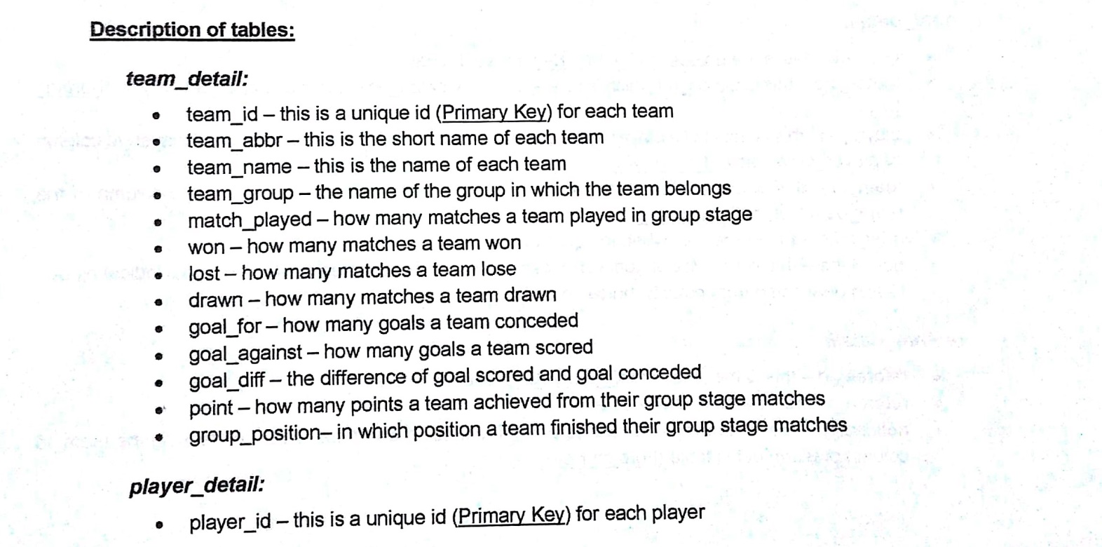

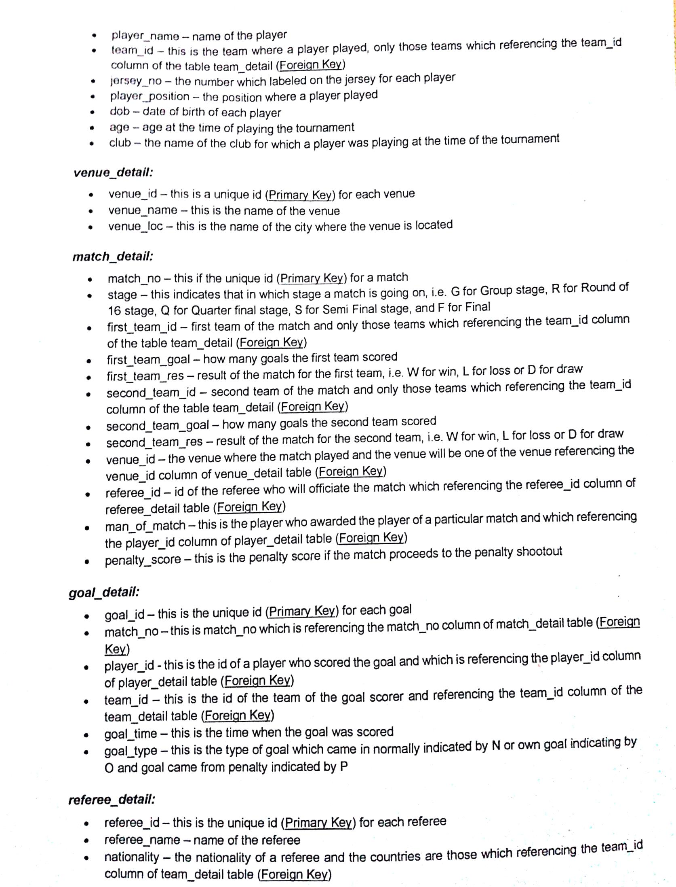

**Schema Diagram:**

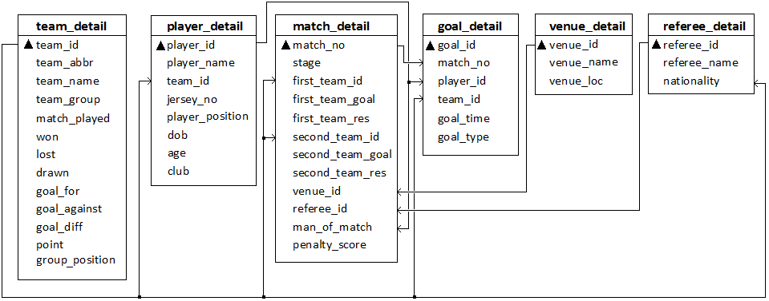

**Functionality :**

The database is designed with some useful user interfaces.

**1. Create tables:**

Tables are created with create table();

*create table referee_detail(*

*referee_id integer not null,*

*referee_name varchar(30) not null,*

*nationality integer,*

*primary key(referee_id),*

*foreign key(nationality) references team_detail(team_id)*

*);*

**2. Insert data:**

Values are inserted with insert into table.

*insert into team_detail(team_id, team_abbr, team_name, team_group, match_played, won, drawn, lost, goal_for, goal_against, point, group_position)*

*values (1, 'MEX','Mexico','A',3,2,1,0,6,4,7,2);*

**3. Function:**

There are functions to see the match per goal and goal per match analytical information of a player and his team. Function mpg for match per goal and gpm for goal per match.

*create or replace function mpg (matcha number, goal number) return number is mp_goal number(3,2);*

*begin*

*mp_goal := matcha/goal;*

*return mp_goal;*

*end mpg;*

*create or replace function gpm (matcha number, goal number) return number is mp_goal number(3,2);*

*begin*

*mp_goal := goal/matcha;*

*return mp_goal;*

*end gpm;*

**4. Trigger**

Age trigger automatically counts the age of a player which is needed for match information. Another trigger named goal_difference trigger will automatically update the point table's goal difference field to find out goal difference from goal scored and goal conceded in matches.

*CREATE OR REPLACE TRIGGER GOAL_DIFF_TRIG*

*BEFORE INSERT OR UPDATE OF goal_diff ON team_detail*

*FOR EACH ROW*

*DECLARE*

*g_dif number;*

*g_for number;*

*g_ag number;*

*BEGIN*

*g_for := :new.goal_for;*

*g_ag := :new.goal_against;*

*g_dif := g_for - g_ag;*

*:new.goal_diff := g_dif;*

*END;*

**5. Cursor**

There is cursor which will print the detailed data of a goal scored by a specific player. It will

goal time, goal type and which match it was scored by the player. Cursor cursor1 is created to show all the goal details of a specific player.

*cursor cursor1 is*

*select p.player_name, t.team_name, g.match_no, g.goal_time, goal_type from player_detail p natural join team_detail t natural join goal_detail g where p.player_name='Cristiano Ronaldo';*

*begin*

*OPEN cursor1;*

*loop*

*FETCH cursor1 INTO c_name, c_team, c_match, c_time, c_type;*

*EXIT WHEN cursor1%notfound;*

*if c_type = 'N' then type_ :='Normal';*

*elsif c_type = 'P' then type_ :='Penalty';*

*elsif c_type = 'O' then type_ :='Own Goal';*

*else type_ :='Others';*

*end if;*

*dbms_output.put_line('Match=' || c_match || ' || ' || c_name||' (' || c_team ||')' ||' || ' || ' Goal time= ' || c_time ||' min Goal type= ' || type_);*

*end loop;*

*CLOSE cursor1;*

**6. Read from file:**

The table venue_detail has been formed and inserted the informations of the match venues, the venue localions and unique venue_id from a excel file named as venue_detail.csv.

*f :=utl_file.fopen('DATABASE','venue_detail.csv','r');*

*if utl_file.is_open(f) then*

*utl_file.get_line(f,line,1000);*

*loop begin*

*utl_file.get_line(f,line,1000);*

*if line is null then exit;*

*end if;*

*dbms_output.put_line(line);*

*v_id:=regexp_substr(line,'[^,]+',1,1);*

*v_name:=regexp_substr(line,'[^,]+',1,2);*

*v_loc:=regexp_substr(line,'[^,]+',1,3);*

*insert into venue_detail(venue_id,venue_name,venue_loc)values(v_id,v_name,v_loc);*

*exception when no_data_found then exit;*

*end;*

*end loop;*

end if;

utl_file.fclose(f);

**Users/audiences :**

The database is for the users who are enjoying football tournaments. They can get all sort of informations of the tournament, every match results, goals, scores, players, officials. It is a full package of a football lovers. It can be used by any users, but only updatable by its admin. Users can not insert data or update data, rather they can only access it as reader.

**Database design process :**

The database is created to give all the detailed informations of football tournaments to the football lovers where they can access the informations of the tournament. Every players name, nationality, kit number, club played in, date of birth, age are included. This player is connected by foreign keys to goal detail taable from where user can get that players goal scoring informations. Again a match is officiated by referees, this referees are connected to match detail table where user can watch which official is in this match.

Again, a match is going on in a venue. In the match table venues is connected from venue table, user can find out the location of that venue and about the playing city. So, inserting match records will automatically affect the other informations to get updated. After that, with pl/sql some functional activities are also performed, which is used to get some analytical data from the tables.

**Features:**

1. Can get informations of players.

2. Can get informations of tournament officials.

3. Can get informations of match venues.

4. Can get informations all goals.

5. Can know match details at a glance.

**Summary:**

The project was a learning experience for me and allowed me to improve upon our SQL, Oracle management, and Toad skills. I have developed a usable application for the football tournaments all over the world with the results of these efforts. I will look forward to seeing the database being put into actual use later.